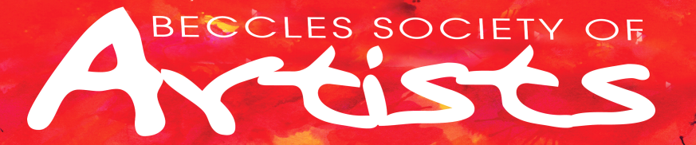

ANNUAL MEMBERSHIP FORM
Jan 1st to Dec 31st 2024

Title/Pronoun Forename
Surname
Address
Telephone
Email
Payment | Bank Transfer yes / no
 | Cheque yes / no
 | Cash yes / no Bring to meeting in named envelo

Please include your email address so we can keep you up to date with the latest information and we can email you relevant documents.

Cheques to be made payable to Beccles Society of Artists or by bank transfer
Account details are: sort code 30 95 24
Acc number 00887804
Lloyds bank
Beccles society of artists
Post to Vice Chair Liz Hynes 15 Elliott Garrood Gardens Beccles NR34 9RA
or bring to the meeting in a named sealed envelop (form and payment) January 3rd 2004

Membership Subscription for 2024 is £30 includes right to enter Annual Exhibition
MUST BE PAID BEFORE OR / AT FIRST MEETING IN JANUARY

Your privacy is important to us, and we want to communicate with Society Members in a way which has their consent, and which is in line with UK law on data protection. As a result of a change in UK law, we now need your consent as to how we contact you. By signing this form you are confirming that you are consenting to the Beccles Society of Artists holding and processing your personal data for the following purposes:
I consent to the Society:
☐ Keeping me informed about news, events and activities of the Society.
☐ Sharing my contact details with the Committee of the Beccles Society of Artists
so they can keep me informed about news, events and activities of the Society.

Signed: _____________________________________________ Dated: __________

You can grant consent to all the purposes; one of the purposes or none of the purposes. Where you do not grant consent we will not be able to use your personal data; (so for example we may not be able to let you know about events or activities); except in certain limited situations, such as where required to do so by law or to protect members of the public from serious harm. You can find out more about how we use your data from our “Privacy Policy” which is available from our website or from the Chairperson.
You can withdraw or change your consent at any time by contacting beccles.bsa.artists@hotmail.com or writing to BSA Chair Mr James Davis 2 Stobart Close Beccles NR34 9LT Please note that all processing of your personal data will cease once you have withdrawn consent, other than where this is required by law, but this will not affect any personal data that has already been processed prior to this point.

